Урок английского языка по теме: “_________________________________”
(3-4 классы)
Student’s worksheet 1: pre-museum activities
Exercise 1 (Задание 1). Match the parts of words and make up the names
of sports. / Соедини части слов и получи названия видов спорта.

hoc | ping
swim | ling
foot | key
wrest | ball
aero | nis
jum | ball
volley | bics
ten | ming

Write the words down: / Запиши слова: _________________________________ ____________________________________________________________________________________________________________________________________
__________________________________________________________________

Exercise 2 (Задание 2). Read the text and do the tasks. / Прочитай текст
и выполни задания.
On the Skating Rink
A Fox, two Hares, a Dog and a Pig want to go to the skating rink. Suddenly they see a big brown Bear.
“Do you want to go to the skating rink with us? We can skate. It’s fun to be on the ice. Let’s go with us.”
“I’d love but I can’t skate. OK… let’s go.”
The ice is blue and nice. Now the Fox is on the ice. She can dance on the ice very well. The Hares cannot dance but they like to skate. The Pig is not a good skater. On and on she falls down. But she wants to skate well.
Then the Bear goes on the ice. He is big and clumsy ¹. He can’t eve stand ² on his skates. The Dog wants to help ³ him and they fall down together.
The Bear does not like it. He is not happy.
“Don’t worry. Be happy,” says the Dog.
____________________
¹ clumsy [‘klʌmzi] – неуклюжий
² even stand [‘i:vn stænd] – даже стоять
³ to help – помогать
True, false or not stated. / Верно, неверно, в тексте не сказано.
1. A Fox, two Hares, a Dog and a Pig want to go the Zoo. _______________
2. They want to go to the skating rink. ______________________________
3. Suddenly they see a penguin. ___________________________________
4. The Pig can dance on the ice very well. ___________________________
5. The Pig skates fast. ___________________________________________
7. The Fox is clumsy. ___________________________________________
8. The Bear can’t skate. __________________________________________
9. The Bear is happy. ____________________________________________
10.The Dog can’t skate. __________________________________________

Exercise 3 (Задание 3). Ancient Athlete Pose / Поза древнего атлета.
Instruction for the teacher: На экране - силуэты людей, занимающихся разными видами спорта.
Look at the silhouettes. Choose one. Repeat the pose. Your classmates must guess what sport it is. / Посмотри на силуэты. Выбери один. Повтори эту позу. Одноклассники должны угадать, какой это вид спорта.
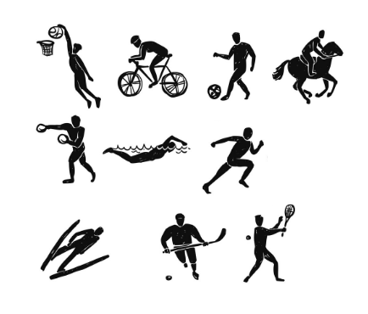
Exercise 4 (Задание 4). Design a team badge. / Придумай эмблему команды.
Instruction for the teacher: продготовить круглые или прямоугольные бумажные «щиты», цветные карандаши.
Draw the badge and tell the class: / Нарисуйте эмблему и расскажите классу:
1. What is the name of your team?
2. What can we see on your badge?
3. What colour is your badge?

